Database Design & Data Modeling
Introduction
This document presents the database design for a HEALEX that integrates a chatbot for patient interactions, symptom extraction using NLP, and prediction of diseases using a machine learning model. The system manages patients, doctors, chat sessions, symptoms, diseases, prediction reports, and appointments.

- Entities
Entity | Description
Patient | Stores the user data who interacts with the chatbot.
Doctor | Contains information about doctors recommended by the system.
Chat Session | Represents each conversation between the patient and the chatbot.
Symptom | Contains the symptoms extracted by the NLP model from chat sessions.
Disease | Represents diseases used by the machine learning model for prediction.
Prediction Report | The report generated after the disease prediction. It is accessible only to doctors.
Appointment | Represents the relationship between a patient and a doctor, including the associated report.

- ER Diagram
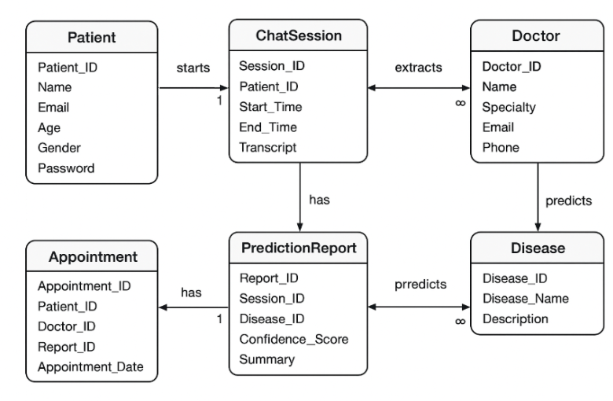

Relationships Description:
- Each Patient can start one or more Chat Sessions.
- Each Chat Session can extract multiple Symptoms.
- The Machine Learning Model uses these symptoms to generate a Prediction Report.
- The Patient then chooses a Doctor, resulting in an Appointment.
- The Prediction Report is associated with the Appointment and is visible only to the doctor.

- Logical Schema
Table | Attributes | Primary Key | Foreign Keys | Notes
Patient | Patient_ID, Name, Email, Age, Gender, Password | Patient_ID |  | Users of the system
Doctor | Doctor_ID, Name, Specialty, Email, Phone | Doctor_ID |  | Doctors in the system
Chat Session | Session_ID, Patient_ID, Start_Time, End_Time, Transcript | Session_ID | Patient_ID → Patient.Patient_ID | Conversation between patient and chatbot
Symptom | Symptom_ID, Symptom_Name, Session_ID | Symptom_ID | Session_ID → ChatSession.Session_ID | Symptoms extracted from chat session
Disease | Disease_ID, Disease_Name, Description | Disease_ID |  | Diseases used for prediction
Prediction Report | Report_ID, Session_ID, Disease_ID, Confidence_Score, Summary | Report_ID | Session_ID → ChatSession.Session_ID, Disease_ID → Disease.Disease_ID | Report generated after prediction (visible only to doctor)
Appointment | Appointment_ID, Patient_ID, Doctor_ID, Report_ID, Appointment_Date | Appointment_ID | Patient_ID → Patient.Patient_ID, Doctor_ID → Doctor.Doctor_ID, Report_ID → PredictionReport.Report_ID | Appointment linking patient, doctor, and report

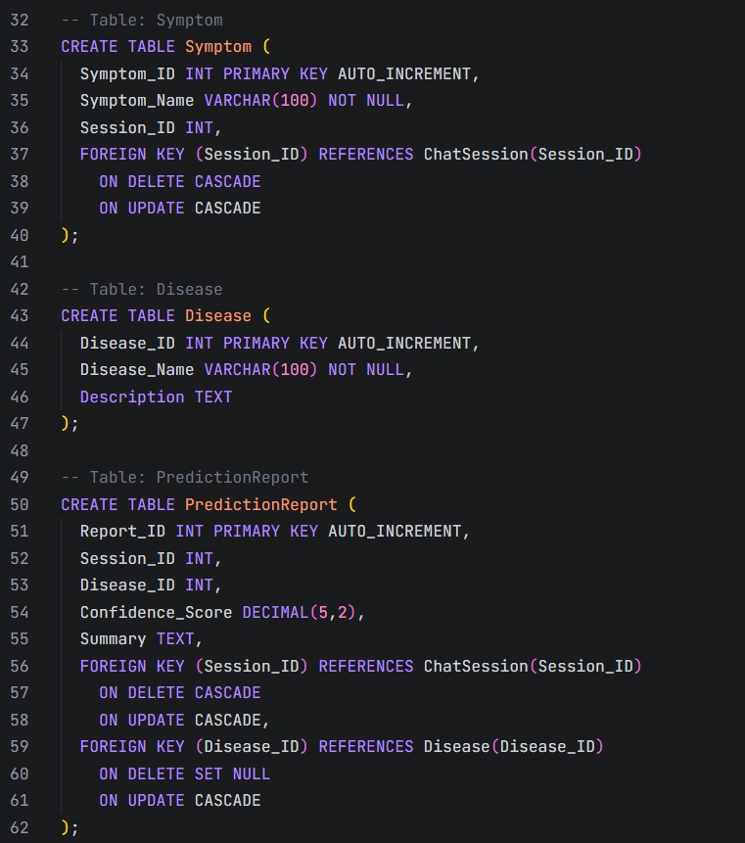
- Physical Schema
